User Manual

Ashoka Elections Voting Portal

By Paras Bhattrai

February 01, 2016

**USAGE INSTRUCTIONS**

1. Process for voting

1. Collect your password slip from volunteers.

2. Enter the password on the election pc screen which looks similar to the screen below.

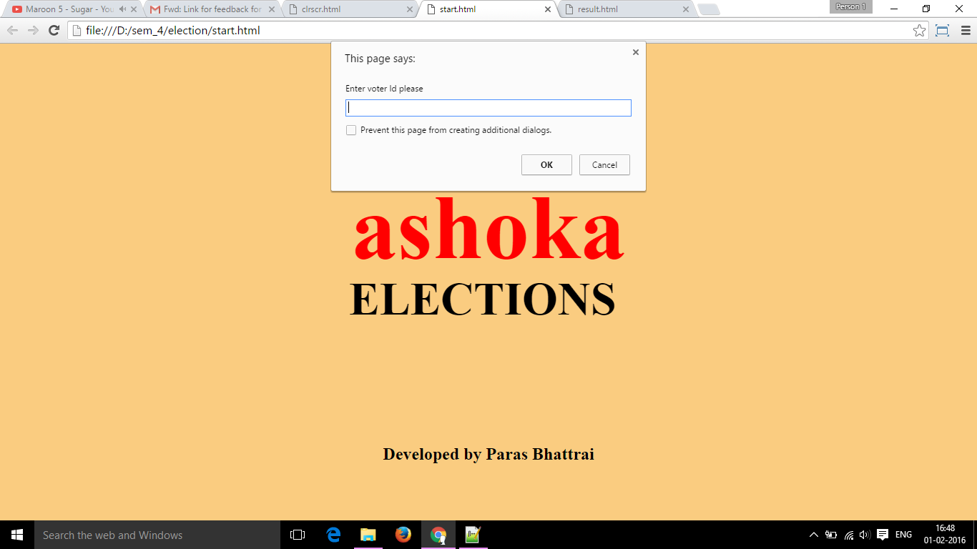

3. After typing the password click OK button.

4. The page will redirect you to the page containing list of all candidates which looks similar to the screen below. If your password is not accepted, you will have to retype the password or get a new slip from volunteers.

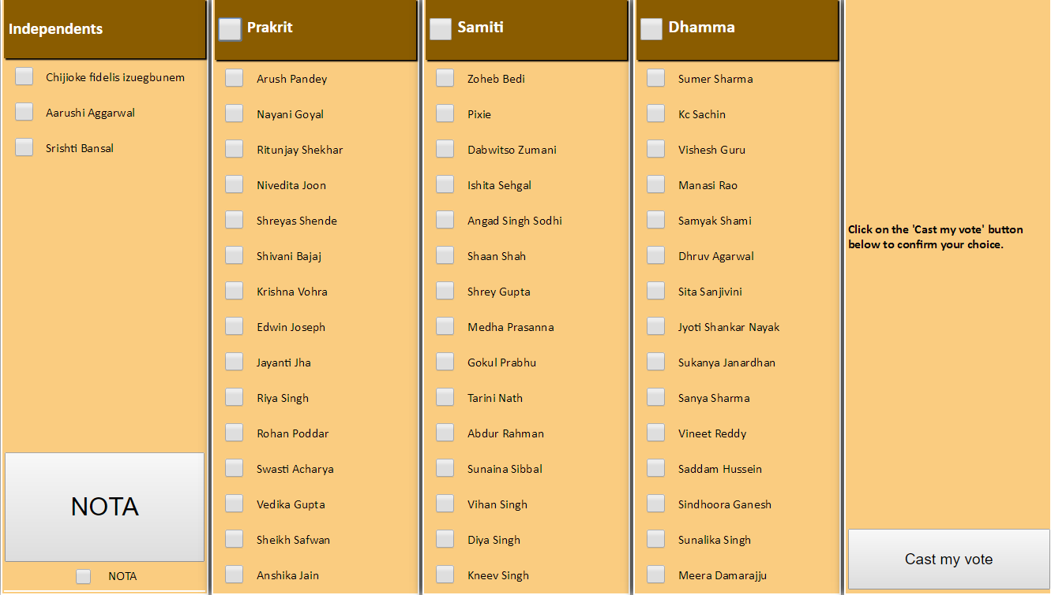

5. The candidate list page provides you with the option of either selecting a complete party list or individuals within a party.

5.1 If you opt to vote for complete party list, select the checkbox near the name of the party. This will check all the names of candidates present in the party list.

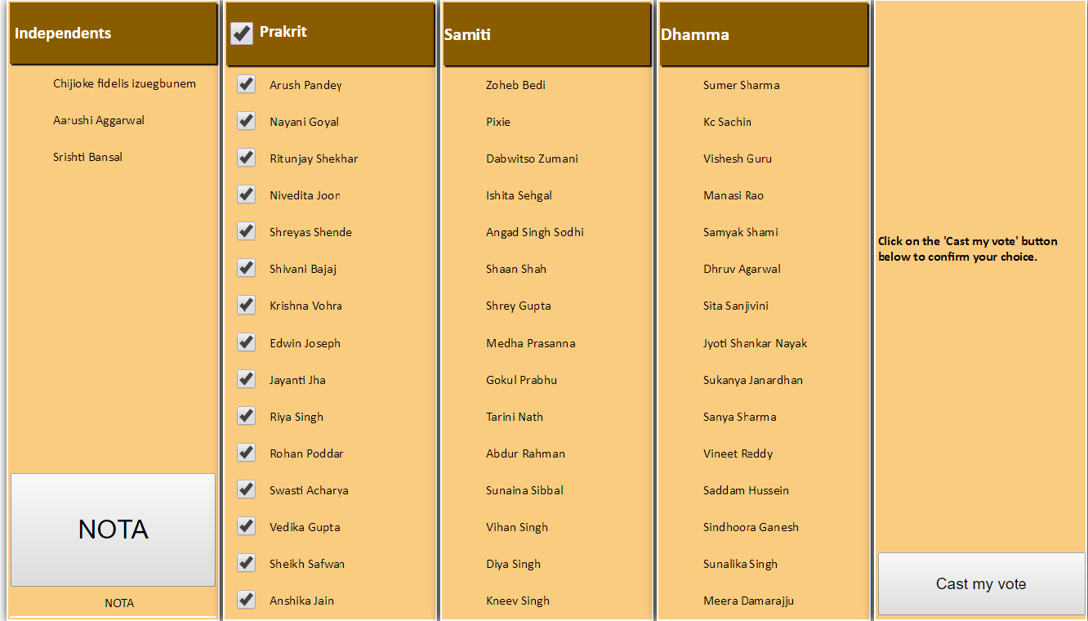

5.2 If you opt to vote for individuals within a party, then instead of selecting the checkbox near party name, click on individual(s) belonging to same party. You cannot vote for individuals belonging to different party.

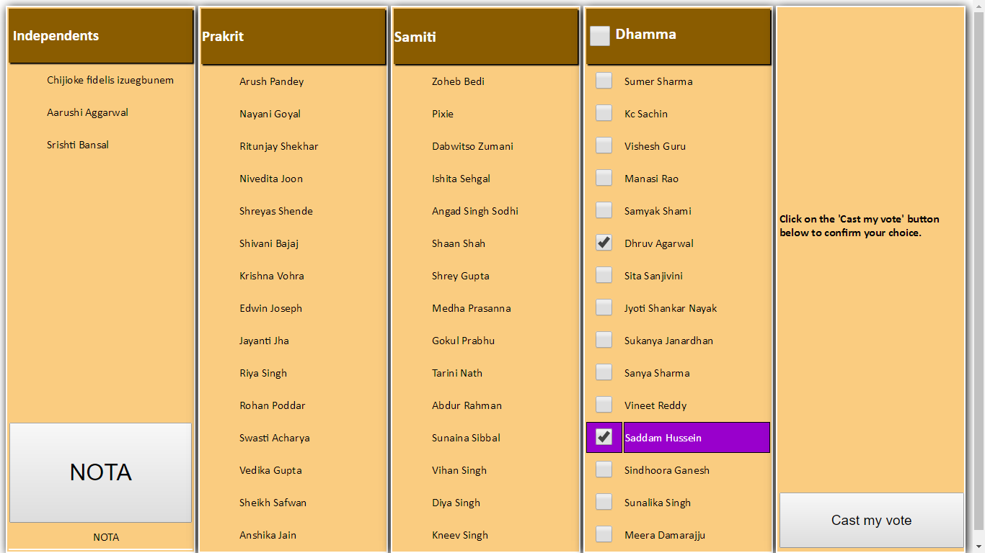

6. Click on ‘Cast my vote’ button. The page will prompt you to save your preference. Click OK button to save.

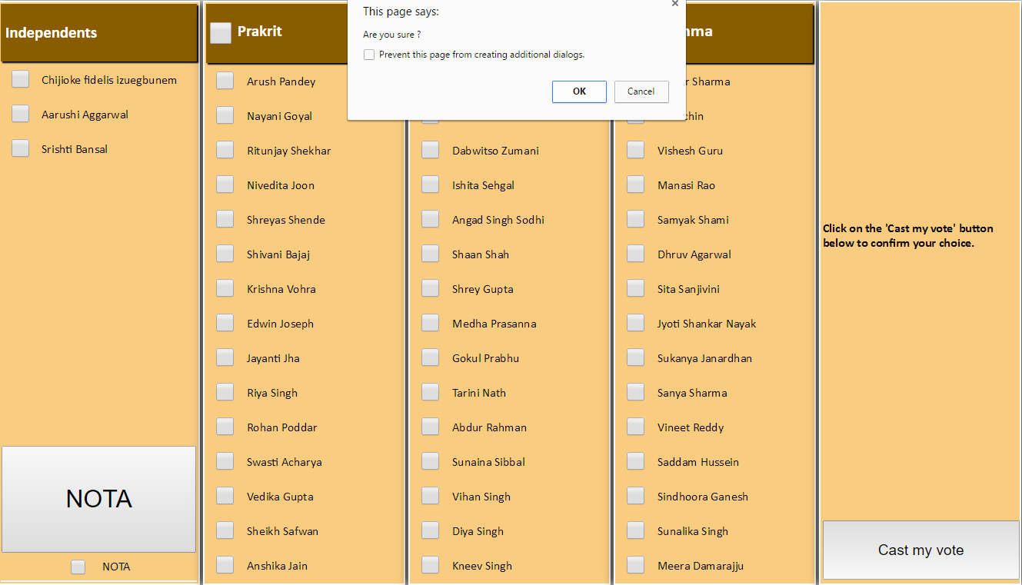

7. The page will redirect you to a ‘Thanks’ page. Your vote is saved.

